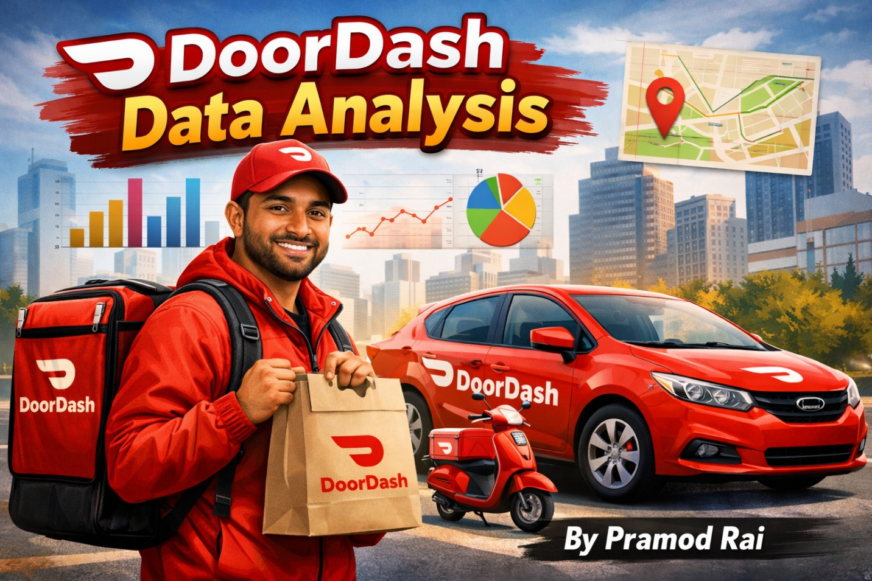

From Raw Data to Insights: DoorDash Customer & Sales Analytics Using Excel

Introduction:
I used to order my lunch from DoorDash back in 2017 when I was at university. Before I did not use DoorDash app that much although the online food delivery concept was pretty much unique idea as well as I was curious about to know their business model like sales, income, age, income, spent capacity, location, time frame, marital status, and JoinedDate because of all these indicators will provide the genuine result to the stakeholders.
I am currently student at DCJ and working on DoorDash Excel Project, when I had this large dataset, I was not sure where to analyze but I started from numbers of rows and columns. Row represents the one customer, and it has 2205 customers and 36 columns (attributes).

In this analysis report, I will be going to find out major business questions

- Compare Total Spent and Campaign 6 spent where Campaign 6 represents approximately 15% of the total customer base
- Campaign 6 contributes around 25% of the Total Revenue where Campaign 6 has only 311 customers
- Customers in Campaign 6 spend approximately 62.7% more per customer compared to the overall average.
- Implement the Scatter Plot to analyze between Income and Total Spent on the DooorDash app
- Income Analysis using Histogram and Observe the mid-income ranges ($31,993–$80,978)

If you want to analyze it, here is dataset link: DoorDash Dataset (https://github.com/nailson/ifood-data-business-analyst-test/blob/master/ifood_df.csv)

Excel Tools and Techniques that I used to analyze the dataset are as follows: Data Cleaning, Aggregation functions(SUM, MIN, MAX, SUBTOTAL). Histogram, Pivot Table, Scatter Plot, Bar Chart, VLOOKUP, XLookUP, and Advanced Formulae(IF, SUMIF, COUNTIF)

First step as being data analyst, I need to clean the dataset by removing duplicates value and finding out the missing value. I added new column as CustomerID as unique value so that each customer will be unique. And then I filtered and sorted the dataset so that I could analyze Campaign 6 column with Total Spent. Based on my analysis report, I analyzed the dataset below in the summary table.

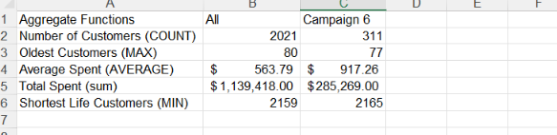

Customer Income Analysis Through Histogram Method
I used Histogram to analyze the Customer Income. Histogram shows how income values are distributed across the dataset. Most observations fall in the mid-income ranges ($31,993–$80,978), indicating a strong concentration of middle-income customers. Lower and higher income groups have fewer observations. Overall, the distribution is slightly right skewed, with incomes clustered around the mid-range.
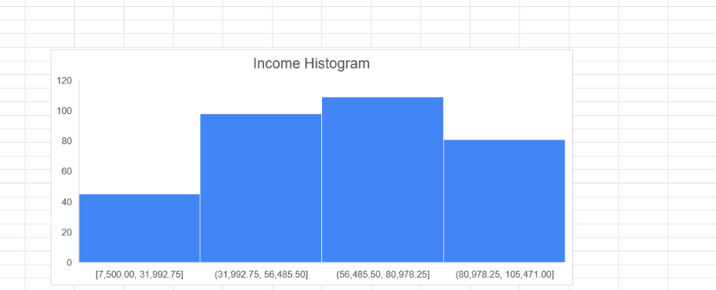

I implemented Scatter plot analyzing the relationship between customer income (X-axis) and total amount spent on DoorDash (Y-axis). Each point represents an individual customer. The upward-sloping trendline indicates a positive correlation between income and spending. The R² value of 0.6774 shows that approximately 68% of the variation in customer spending is explained by income, making income a strong predictor of total spend.

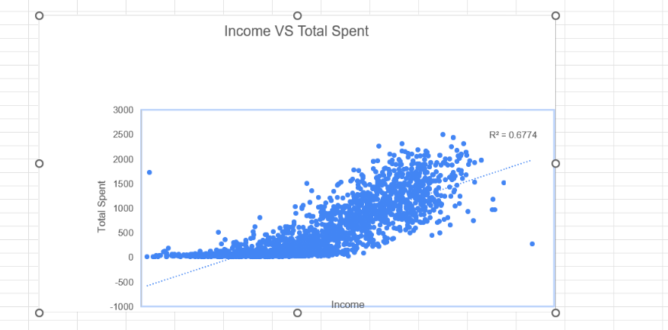

Pivot Table for Campaign 6 Spent Analysis
I used the Pivot Table to analyze Campaign 6 Spent. From this Pivot table, customers who accepted the Campaign 6 have much higher average spend (~$917) compared to non-acceptors.
Here is how I calculated -
Sum of MntTotal = $285,269
Count of MntTotal = 311
Average Spent = 285 , 269 /311 = 917.26

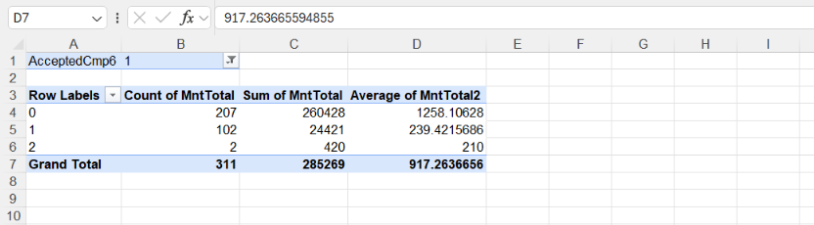

VLOOKUP
VLOOKUP searches for a value (like a Customer ID) in the first column of a table and returns a related value from Total Spent by Customer in the same row.

VLOOKUP formula that I used for
=VLOOKUP(lookup_value, table_array, col_index_num, [range_lookup])
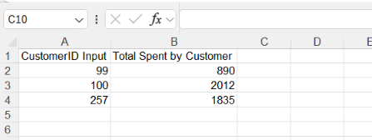

XLOOKUP
XLOOKUP finds a value (Customer ID) in one column and returns the matching result from Total Spent by Customer, and it can look both left and right.
It is more flexible than VLOOKUP because it does not require the lookup column to be the first column and handles missing values better.

XLOOKUP formula that I used for
=XLOOKUP(lookup_value, lookup_array, return_array, [if_not_found], [match_mode], [search_mode])

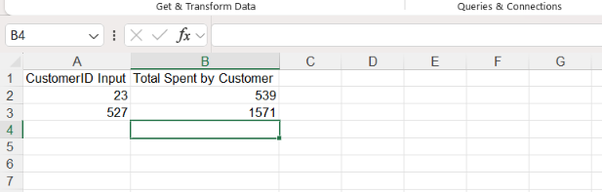

My excel Badge

Conclusion
Campaign 6 demonstrates strong revenue efficiency, generating approximately 25% of total revenue despite representing only about 15% of the customer base (311 customers), indicating a high-value customer segment. Per-customer spending in Campaign 6 is ~62.7% higher than the overall average, confirming superior monetization effectiveness. Scatter plot analysis reveals a positive correlation between income and total spend on the DoorDash app, while histogram analysis shows that mid-income customers ($31,993–$80,978) form the core spending group, suggesting this income range is optimal for targeted, high-ROI campaigns.

Let's Connect
Thank you for taking the time to read my analysis. I’d love to turn this into a conversation if you have feedback, concerns, suggestions, or questions, please share them in the comments.
I would like to connect with you all on LinkedIn
https://www.linkedin.com/in/pramod-raida201/

